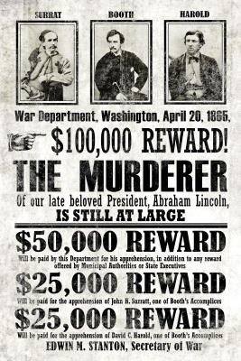
Wanted Poster
Wanted poster for John Wilkes Booth. This is the first wanted poster to use pictures to help capture fugitives.
1.) Sign up for a person with Mrs. Keaton.
2.) Create a Wanted Poster for your person from a BRITISH POINT OF VIEW.
3.) You will need to research your person and figure out what accomplishments they did during the American Revolution. Turn those positive things into things that the British would have found negative. For example, Paul Revere would be wanted by the British for rallying the colonists by painting The Bloody Massacre and for warning every one of their plan of attack by riding through the night.
4.) Include this information on your Wanted Poster: image (hand-drawn), description why they are wanted, contact information, and a reward*.
*We did not use dollars in the 1700s but rather pounds. Look up what that symbol looks like.

Due on Wednesday, September 30th/Thursday, October 1st.

Wanted Poster
Wanted poster for John Wilkes Booth. This is the first wanted poster to use pictures to help capture fugitives.
1.) Sign up for a person with Mrs. Keaton.
2.) Create a Wanted Poster for your person from a BRITISH POINT OF VIEW.
3.) You will need to research your person and figure out what accomplishments they did during the American Revolution. Turn those positive things into things that the British would have found negative. For example, Paul Revere would be wanted by the British for rallying the colonists by painting The Bloody Massacre and for warning every one of their plan of attack by riding through the night.
4.) Include this information on your Wanted Poster: image (hand-drawn), description why they are wanted, contact information, and a reward*.
*We did not use dollars in the 1700s but rather pounds. Look up what that symbol looks like.

Due on Wednesday, September 30th/Thursday, October 1st.

