**Revolutionary War Tissue Box**

**Purpose:** Students will create a Revolutionary War Tissue Box as a review tool for people, events and dates.

**Grading:** Awesome projects will receive full credit. Substandard products will receive fewer points. Not following instructions will result in lower points or having the product rejected. Take your time, use your brain and ask questions if needed to ensure you receive full credit.

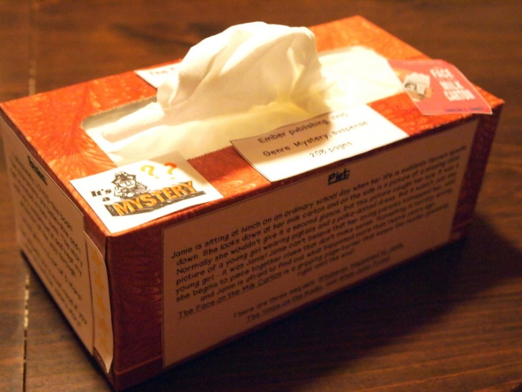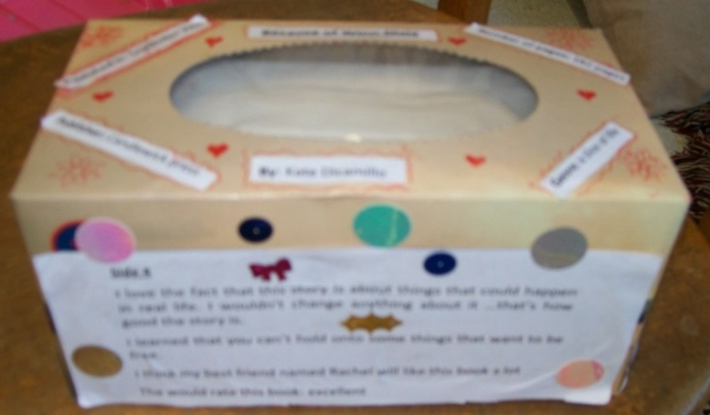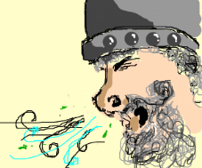

***The Do’s:***

* You must **NEATLY** decorate the tissue box with construction or butcher paper or paint the box/paper.
* The box of tissues must be large and rectangular. Thin rectangular or small square shaped boxes will not be accepted.
* *Be sure to cut a hole in the construction paper (or other covering) which allows the tissues to be dispensed.*
* On the box you will display:
  + Top – Title for project
  + Long Side #1- Pre-Revolutionary Events
    - Name & year of 3 most important events
    - Brief description of why significant
    - Image to represent
  + Long Side #2 – Key People
    - 5 people
    - Name
    - Image
    - Brief description of role
  + Short Side #1 – Battles
    - Chronological order on timeline
      * Lexington & Concord
      * Bunker Hill
      * Saratoga
      * Yorktown
    - Significance of each
  + Short Side #2 – Primary Source
    - Choose one primary source
  + Bottom – Name & Period
* Search your textbook and notes for ideas.
* There must be visuals to convey the topic– maps, photos, diagrams, charts, drawings, etc.
* Be creative, neat and colorful.

***The Don’ts:***

* **NO GLITTER!!!!!!** Nothing with glitter on it will be accepted. It’s the gift that keeps on giving!
* **NO DIRT OR PLANT MATERIAL!** Please do not glue or plant material dirt to the top of the box.
* Do not use any material that you would not want to show up on a tissue someone would use to wipe their nose.

**Due Dates:**

**October 15th (A-Day) &**

**October 16th (B-Day)**

**Questions? Let me know. Stop by or E-mail me!**