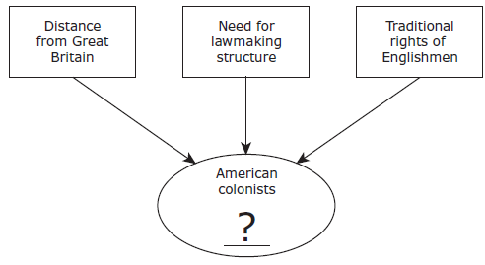

1860 Census Results for Selected States

|  |  |  |  |
| --- | --- | --- | --- |
| State | Total Population | Total Number of Slaves | Slaves as a % of Population |
| Alabama | 964,201 | 435,080 | 45% |
| Georgia | 1,057,286 | 462,198 | 44% |
| Kentucky | 1,155,084 | 225,483 | 20% |
| Maryland | 687,049 | 87,189 | 13% |
| Mississippi | 791,305 | 436,631 | 55% |
| Virginia | 1,596,318 | 490,865 | 31% |

|  |  |  |  |
| --- | --- | --- | --- |
| Characteristics of American Colonies | | | |
| Colonies | Resource | Climate | Product |
| Northern | Deep harbors | Cold | 1 |
| Middle | Rich farmland | 2 | Livestock |
| Southern | 3 | Warm | 4 |

1. Which characteristic is correctly matched with a number in the table?

**A** 1: Indigo

**B** 2: Moderate

**C** 3: Rocky soil

**D** 4: Ships

4. This data could be used to support which conclusion?

**A** Gulf Coast states had to rely on steamboats to transport goods.

**B** States in the lower South had more land devoted to plantations.

**C** Border states had to import needed raw materials.

**D**  States in the upper South were heavily industrialized.

3. Which of the following best replaces the question mark in the diagram?

**A** Created a general council to manage the colonies

**B** Experienced strict control by Parliament

**C** Established their own representative institutions

**D** Appointed governors who reported to the king

1. Which statement best explains the significance of the Mayflower Compact?

**A** It limited the power of future colonial governments.

**B** It weakened the influence of religion in government.

**C** It established a form of self-government based on a social contract.

**D** It guaranteed liberties for colonists through local government.

1. Catholics immigrated to the Maryland colony in the seventeenth century primarily to —

**A** profit from natural resources

**B** avoid crop failures and famine

**C** produce cash crops to pay off debts

**D** escape persecution

***Directions****: Read each question carefully. Determine the best answer to the question from the four answer choices provided.*

**WARM UP (Colonies) #1**

Name __________________________ Period _____