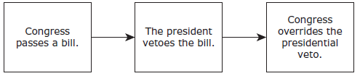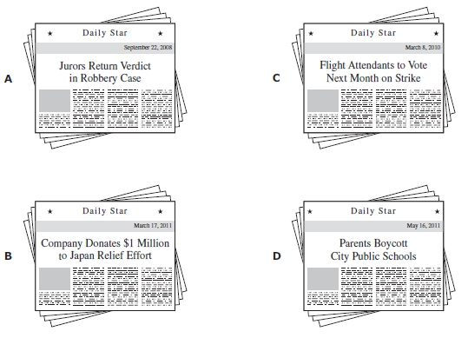

Your President may easily become king. Your Senate is so imperfectly constructed that your dearest rights may be sacrificed by what may be a small minority… Your strongholds will be in the hands of your enemies…

*—Patrick Henry, speech at the Virginia Ratifying Convention, 1788*

7. Patrick Henry was criticizing which aspect of the Constitution in this excerpt?

**A** The eligibility requirements for congressional office

**B** The power granted to the central government

**C** The establishment of a separate judicial branch

**D** The difficulty of the amendment process

6. George Mason refused to sign the Constitution and opposed its ratification because he believed that it —

**A** did not adequately protect individuals from potential government abuse

**B** did not give the executive branch enough power to oversee the military

**C** prevented the legislative branch from effectively governing the states

**D** prevented the judicial branch from using judicial review to overturn acts of the legislature

5. Which principle of U.S. government is illustrated in the sequence shown below?

**A** Judicialreview

**B** Checksandbalances

**C** Popularsovereignty

**D** Federalism

And excessive bail hath been required of persons committed in criminal cases to elude the benefit of the laws made for the liberty of the subjects; And excessive fines have been imposed; And illegal and cruel punishments inflicted . . .

*—English Bill of Rights, 1689*

4. Which U.S. document guarantees protection against these injustices?

**A** The Constitution

**B** The Declaration of Independence

**C** The Articles of Confederation

**D** The Mayflower Compact

2. When citizens report for jury duty, they are helping uphold a constitutional right guaranteed by the —

**A** First Amendment

**B** Second Amendment

**C** Sixth Amendment

**D** Ninth Amendment

3. Patrick Henry opposed ratifying the U.S. Constitution because he believed that under it —

**A** the states would surrender too much power to the federal government

**B** alliances could not be formed with other countries

**C** the courts would not be able to hold government officials accountable

**D** individuals would exercise too much power over the federal government

1. Which headline provides the best example of a civic duty?

**A B C D**

***Directions****: Read each question carefully. Determine the best answer to the question from the four answer choices provided.*

**WARM UP (Constitution) #3**

Name __________________________ Period _____