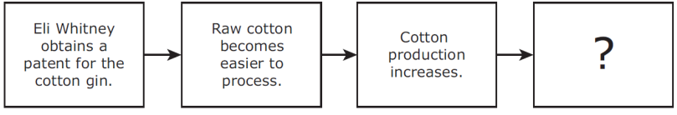

7. How did the factory system contribute to the rapid industrialization of the United States?

1. By using slave labor to mass-produce goods
2. By relying on skilled artisans to create custom goods
3. By making the production of goods more efficient
4. By making the distribution of goods less costly

6. In 1832 the Supreme Court ruled that Georgia did not have legal authority over the Cherokees living in the state. President Andrew Jackson responded to this decision by —

1. filing another petition against the Cherokee Nation
2. ignoring the ruling and allowing Georgia to evict the Cherokee Nation
3. ordering state officials in Georgia to negotiate with the Cherokee Nation
4. asking Congress to pay reparations to the Cherokee Nation

5. Which of these characteristics also describes these two states?

**A** Founded as work colonies for debtors

**B** Former slave states

**C** Were havens for religious dissenters

**D** Former Spanish colonies

**Characteristics of**

**California and Florida**

• Good climates for agriculture

• Long coastlines with natural harbors and bays

• Originally inhabited by American Indians

4. The Compromise of 1850 allowed certain territories to use popular sovereignty to determine whether the territory would be free or slave. This decision applied to much of the land gained from the —

**A** Revolutionary War

**B** War of 1812

**C** U.S.-Mexican War

**D** Civil War

3. Which of these best completes the diagram?

**A** The demand for slaves increases in the South.

**B** More textile factories are established in the South.

**C** The number of European immigrants arriving at southern port cities increases.

**D** More tobacco and food crops are cultivated on southern plantations.

2. Which statement best describes a result of industrialization in the United States during the mid-nineteenth century?

**A** People moved to cities in search of economic opportunity.

**B** Farmers began to cultivate land west of the Appalachian Mountains.

**C** Native peoples were forcibly relocated to western territories.

**D** Government officials began to promote the idea of Manifest Destiny.

1. Conflicting interpretations of this amendment played a major role in the —

**A** Bank War

**B** Nullification Crisis

**C** Corrupt Bargain

**D** XYZ Affair

**Jackson/**

**Growth of a Nation**

***Directions****: Read each question carefully. Determine the best answer to the question from the four answer choices provided.*

**WARM UP ( ) #5**

Name __________________________ Period _____